CHAPTER FOUR
RESULTS AND INTERPRETATION

4.1 Descriptive Statistics and Parity Distribution
A total of 261,544 registered live births were included in the final cleaned analytical dataset after removing records with missing values in key variables and implausible maternal age entries. The distribution of birth order across the nine parity categories is presented in Figure 4.1 and summarized below.
First-born children (parity = 1) accounted for 40.8% of all registered births, making this the single largest birth order group. The proportion of births declined progressively with increasing birth order, which is consistent with the fertility transition documented in Sri Lanka since the 1960s (UNFPA, 2017). Higher-order births (parity ≥ 5) collectively represented a small minority of the total, reflecting the low total fertility rate — approximately 2.0 children per woman — that characterizes Sri Lanka's demographic profile during the study period (World Bank, 2025).
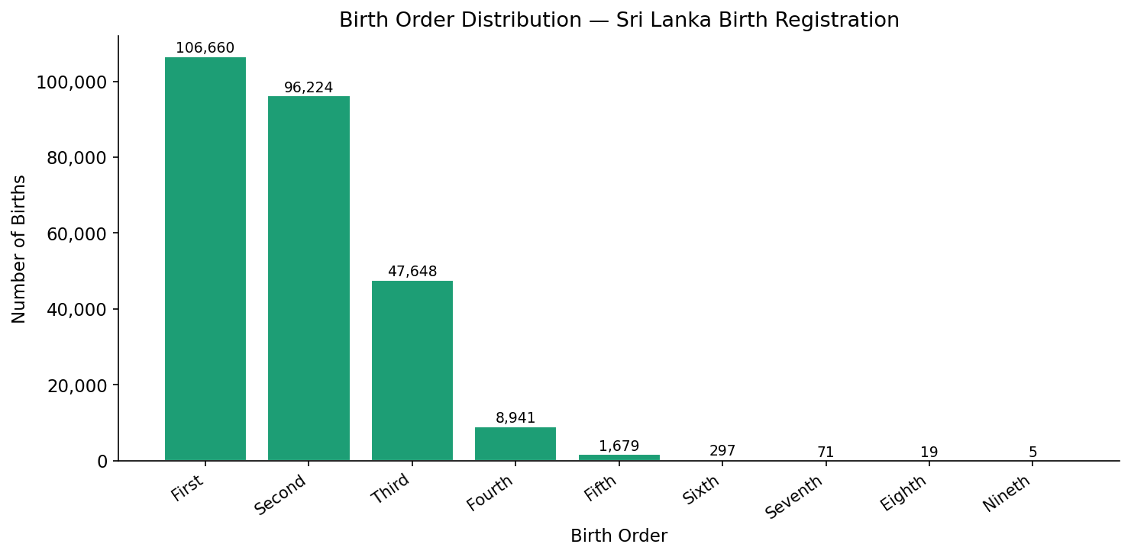
Figure 4.1: Birth order distribution — count and percentage share

4.1.1 Maternal Age by Birth Order
Maternal age at birth increased systematically with birth order, as shown in Figure 4.2. Mothers of first-born children were concentrated in the 20–29 age group, while mothers of higher-order births (parity ≥ 4) were predominantly aged 30 years and above. This pattern reflects the sequential nature of childbearing — higher-order births necessarily occur later in a woman's reproductive life course. The age group composition bars confirm that very young mothers (aged under 20) contribute a disproportionately higher share of first births relative to later births.
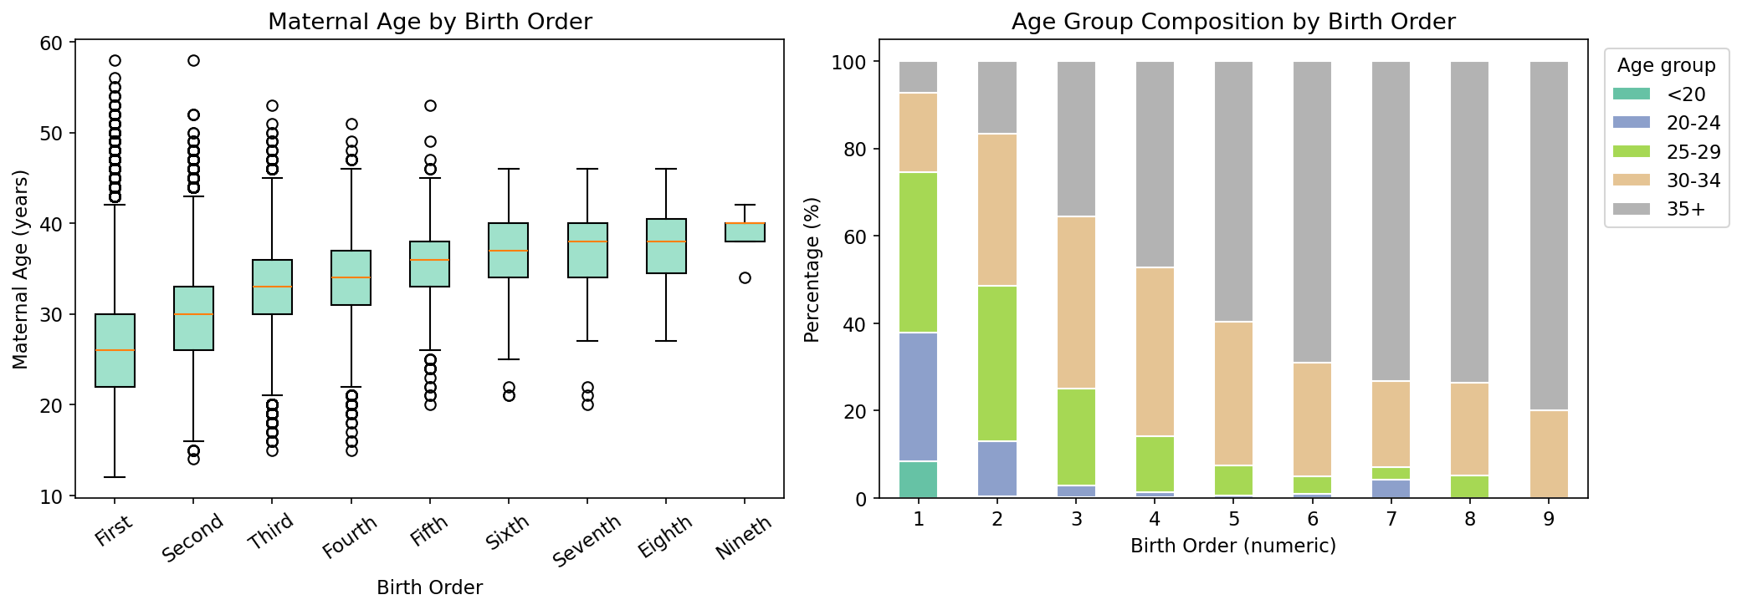
Figure 4.2: Maternal age distribution by birth order

4.1.2 Maternal and Birth Characteristics by Parity Group
Figure 4.3 displays the proportion of first births versus later births across the six categorical predictor variables. Noteworthy patterns include differences in first-birth proportions across marital status categories, race of mother, and place of delivery. Hospital births showed a higher proportion of first-born children relative to non-hospital births, consistent with findings in the broader obstetric literature linking primiparity with higher health-seeking behaviour. Birth weight distributions by birth order (Figure 4.4) indicate that first-born children tend to have marginally lower birth weights compared to second and third-order births, a phenomenon documented in the obstetric literature as the parity–birth weight effect.
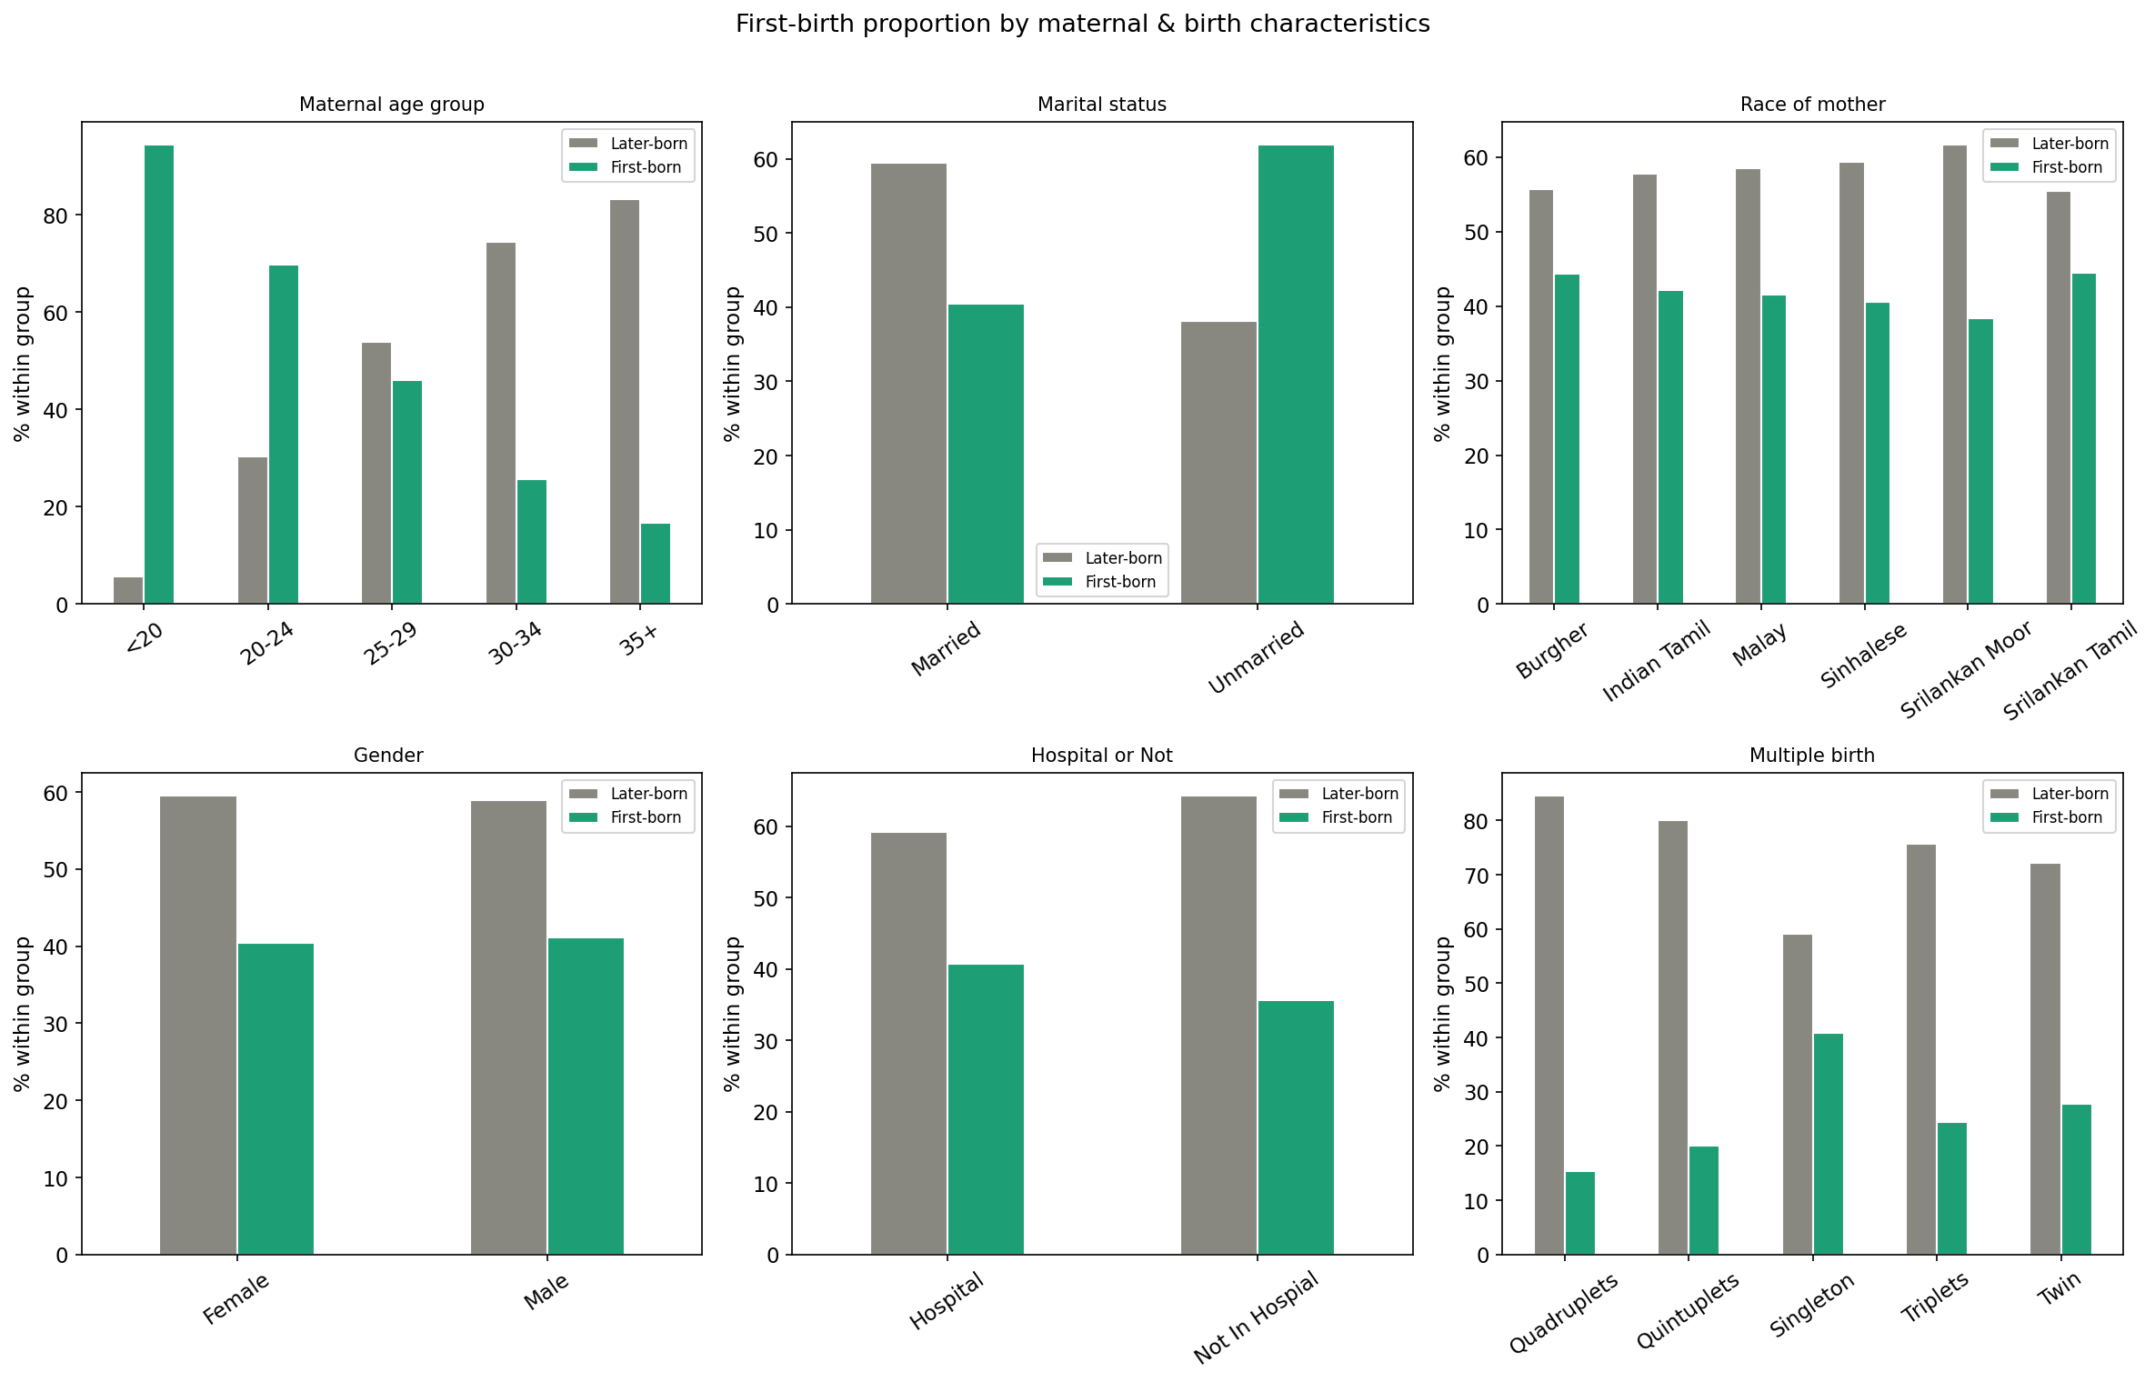
Figure 4.3: First-birth proportion by maternal and birth characteristics
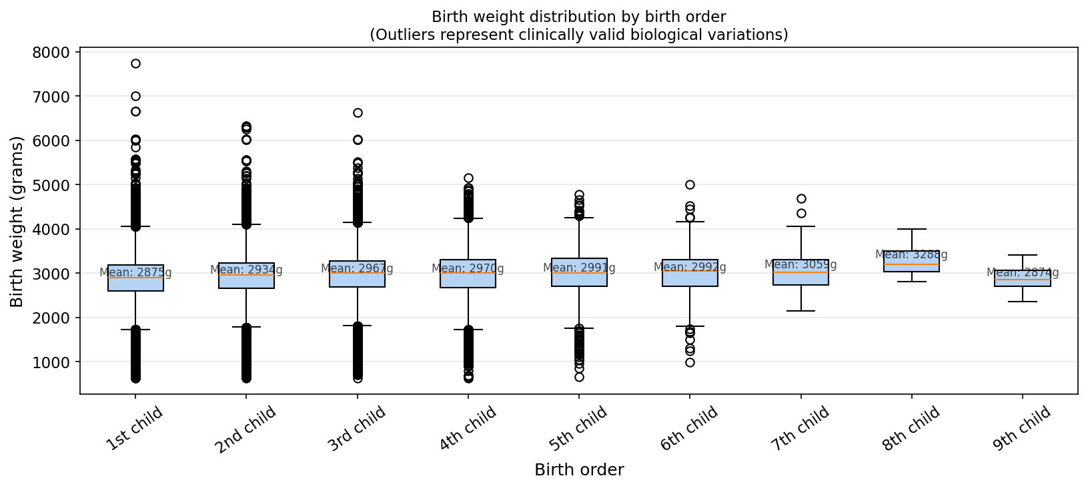
Figure 4.4: Birth weight distribution by birth order

4.2 Chi-Square Tests of Association
Prior to regression modelling, chi-square tests of independence were conducted to assess the bivariate association between birth order and each categorical predictor variable. The null hypothesis for each test states that birth order is independent of the predictor variable. Results are presented in Table 4.1.
Table 4.1: Chi-Square Test Results — Predictor Variables vs Birth Order
index | Variable | Chi2 | df | p-value | Significant
0 | age_group | 62,411.12 | 32 | 0.0000 | Yes ***
1 | marital_status | 757.2700 | 8 | 0.0000 | Yes ***
2 | race_mother | 4,701.93 | 40 | 0.0000 | Yes ***
3 | Gender | 17.9200 | 8 | 0.0218 | Yes ***
4 | Hospital or Not | 369.4300 | 8 | 0.0000 | Yes ***
5 | multiple_birth | 402.8500 | 32 | 0.0000 | Yes ***

The chi-square tests revealed that the following variables were statistically significantly associated with birth order at the 5% significance level: age_group, marital_status, race_mother, Gender , Hospital or Not, multiple_birth. In contrast, none did not demonstrate a statistically significant association with birth order (p > 0.05). All statistically significant variables were retained in the subsequent multivariable regression models.

4.3 Model 1: Ordinal Logistic Regression

4.3.1 Model Specification and Statistical Equation
The Proportional Odds Model (POM) is specified as follows. Let Y denote birth order with ordered categories j = 1, 2, …, 9, and let x₁, x₂, …, xₖ denote the k predictor variables. The cumulative probability up to and including category j is denoted P(Y ≤ j | x). The model is expressed as:
logit[ P(Y ≤ j | x) ] = αⱼ − (β₁x₁ + β₂x₂ + ⋯ + βₖxₖ) (4.1)
where αⱼ (j = 1, 2, …, 8) are the eight threshold parameters (intercepts) representing the log-cumulative odds when all predictors equal zero, and β₁ through βₖ are the regression coefficients common across all cumulative splits — the defining constraint of the proportional odds assumption. The model is estimated by maximum likelihood. The exponentiated coefficients exp(β) are interpreted as cumulative odds ratios (OR): an OR greater than 1 indicates that the predictor is associated with a higher birth order, while an OR less than 1 indicates an association with lower birth order.

4.3.2 Proportional Odds Assumption Check
The proportional odds assumption was evaluated by fitting eight separate binary logistic regression models, each using a different cumulative dichotomization of birth order as the outcome (parity > 1, parity > 2, …, parity > 8). Under the proportional odds assumption, the regression coefficients should remain approximately stable across all eight dichotomizations. Figure 4.5 displays the coefficient trajectories for each predictor across the eight cutpoints.
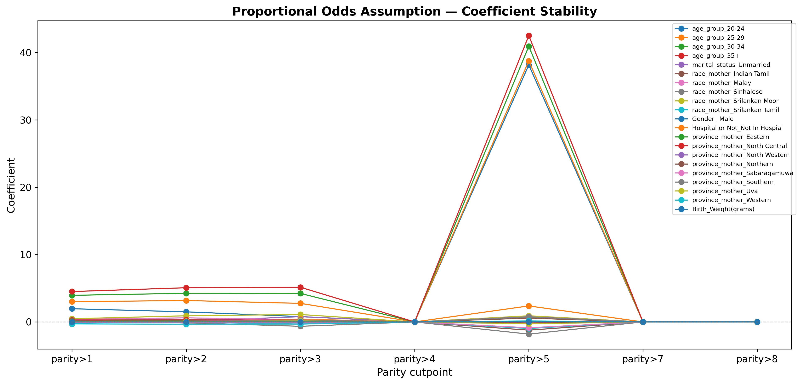
Figure 4.5: Proportional odds assumption — coefficient stability by cutpoint
Lines that remain approximately flat and parallel across cutpoints provide support for the proportional odds assumption. Lines that cross or diverge substantially indicate a potential violation for that predictor. Where minor instability is observed, results should be interpreted with caution and a partial proportional odds model may be considered as a robustness check in future work.

4.3.3 Ordinal Logistic Regression Results
The estimated cumulative odds ratios with 95% confidence intervals and p-values from the Proportional Odds Model are presented in Table 4.2 and visualized as a forest plot in Figure 4.6.
Table 4.2: Model 1 — Ordinal Logistic Regression: Cumulative Odds Ratios
Predictor | OR | 95% CI Lower | 95% CI Upper | p-value | Sig.
age_group_20-24 | 7.0850 | 6.4770 | 7.7500 | 0.0000 | ***
age_group_25-29 | 21.5030 | 19.6810 | 23.4950 | 0.0000 | ***
age_group_30-34 | 58.4610 | 53.4870 | 63.8980 | 0.0000 | ***
age_group_35+ | 127.7510 | 116.7730 | 139.7620 | 0.0000 | ***
marital_status_Unmarried | 0.9940 | 0.9170 | 1.0770 | 0.8811 | nan
race_mother_Indian Tamil | 1.0910 | 0.8690 | 1.3700 | 0.4537 | nan
race_mother_Malay | 1.5650 | 1.1610 | 2.1100 | 0.0033 | **
race_mother_Sinhalese | 0.9030 | 0.7210 | 1.1310 | 0.3761 | nan
race_mother_Srilankan Moor | 2.0440 | 1.6300 | 2.5630 | 0.0000 | ***
race_mother_Srilankan Tamil | 0.8670 | 0.6910 | 1.0890 | 0.2206 | nan
Gender _Male | 0.9640 | 0.9490 | 0.9780 | 0.0000 | ***
Hospital or Not_Not In Hospial | 1.1500 | 0.9190 | 1.4380 | 0.2227 | nan
province_mother_Eastern | 1.2470 | 1.2030 | 1.2930 | 0.0000 | ***
province_mother_North Central | 1.3370 | 1.2890 | 1.3870 | 0.0000 | ***
province_mother_North Western | 1.1200 | 1.0760 | 1.1650 | 0.0000 | ***
province_mother_Northern | 1.0950 | 1.0460 | 1.1450 | 0.0001 | ***
province_mother_Sabaragamuwa | 0.9110 | 0.8850 | 0.9370 | 0.0000 | ***
province_mother_Southern | 1.0220 | 0.9970 | 1.0490 | 0.0904 | nan
province_mother_Uva | 1.0860 | 1.0530 | 1.1190 | 0.0000 | ***
province_mother_Western | 0.7260 | 0.7100 | 0.7420 | 0.0000 | ***
Birth_Weight(grams) | 1.0000 | 1.0000 | 1.0000 | 0.0000 | ***

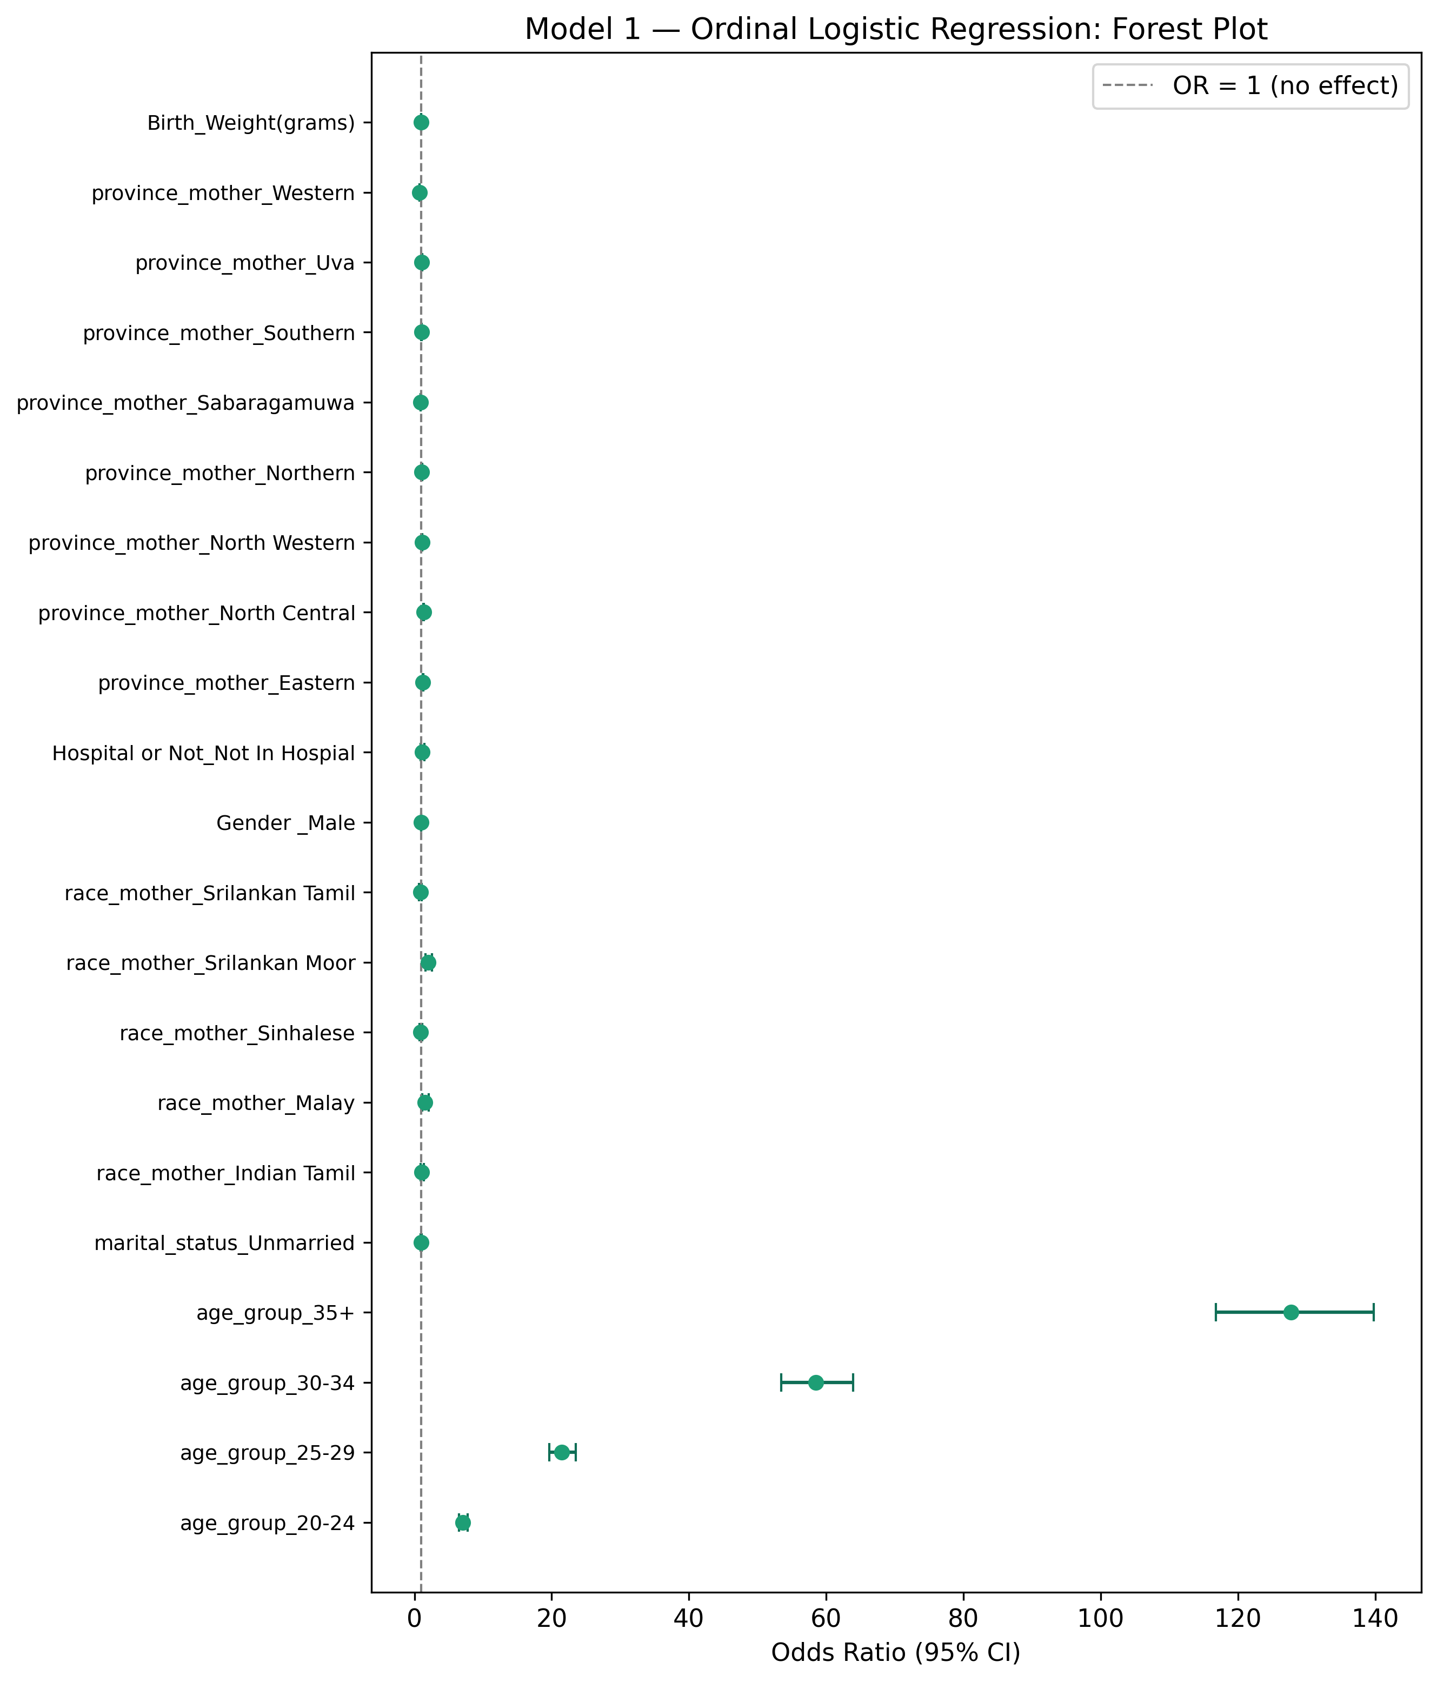
Figure 4.6: Model 1 — Ordinal Logistic Regression: Forest Plot of Odds Ratios

4.3.4 Interpretation of Key Findings
The predictor age_group_20-24 was statistically significant (OR = 7.085, 95% CI: 6.477–7.750, p = 0.0000), indicating that this factor is associated with a higher birth order after controlling for all other variables in the model.
The predictor age_group_25-29 was statistically significant (OR = 21.503, 95% CI: 19.681–23.495, p = 0.0000), indicating that this factor is associated with a higher birth order after controlling for all other variables in the model.
The predictor age_group_30-34 was statistically significant (OR = 58.461, 95% CI: 53.487–63.898, p = 0.0000), indicating that this factor is associated with a higher birth order after controlling for all other variables in the model.
Predictors whose 95% confidence intervals for the cumulative OR excluded the null value of 1.0 are considered statistically significant. Predictors for which the confidence interval includes 1.0 are not statistically distinguishable from no effect at the 5% significance level.

4.4 Model 2: Count Regression

4.4.1 Dispersion Test and Model Selection
Before selecting between Poisson and Negative Binomial regression, the dispersion of the parity variable was assessed. The mean parity was 1.8685 and the variance was 0.7957, yielding a dispersion ratio (variance / mean) of 0.4259.
The dispersion ratio of 0.4259 is less than 1.0, indicating underdispersion. Standard Poisson regression was applied with robust standard errors to account for this.

4.4.2 Statistical Equations
The Poisson regression model is specified as:
log(μᵢ) = β₀ + β₁x₁ᵢ + β₂x₂ᵢ + ⋯ + βₖxₖᵢ (4.2)
where μᵢ = E(Yᵢ) is the expected birth order count for observation i. The Negative Binomial model extends this by adding an observation-level random effect εᵢ to account for overdispersion:
log(μᵢ) = β₀ + β₁x₁ᵢ + ⋯ + βₖxₖᵢ + εᵢ, εᵢ ~ Gamma(1/θ, θ) (4.3)
yielding a marginal variance of Var(Yᵢ) = μᵢ + μᵢ²/θ, where θ is the dispersion parameter estimated from the data. Exponentiated coefficients exp(β) are interpreted as Incidence Rate Ratios (IRR): an IRR > 1 indicates the predictor is associated with a higher expected birth order count, while IRR < 1 indicates a lower expected count.

4.4.3 Poisson Regression Results
The Incidence Rate Ratios (IRR) with 95% confidence intervals estimated from the Poisson regression model are presented in Table 4.3.
Table 4.3: Model 2 — Poisson Regression: Incidence Rate Ratios
Predictor | IRR | 95% CI Lower | 95% CI Upper | p-value | Sig.
age_group_20-24 | 1.2520 | 1.2260 | 1.2790 | 0.0000 | ***
age_group_25-29 | 1.6100 | 1.5770 | 1.6430 | 0.0000 | ***
age_group_30-34 | 2.0220 | 1.9820 | 2.0640 | 0.0000 | ***
age_group_35+ | 2.3780 | 2.3300 | 2.4280 | 0.0000 | ***
marital_status_Unmarried | 1.0160 | 0.9900 | 1.0440 | 0.2276 | nan
race_mother_Indian Tamil | 1.0160 | 0.9330 | 1.1060 | 0.7200 | nan
race_mother_Malay | 1.1030 | 0.9870 | 1.2330 | 0.0839 | nan
race_mother_Sinhalese | 0.9700 | 0.8920 | 1.0550 | 0.4808 | nan
race_mother_Srilankan Moor | 1.1750 | 1.0800 | 1.2790 | 0.0002 | ***
race_mother_Srilankan Tamil | 0.9680 | 0.8890 | 1.0540 | 0.4582 | nan
Gender _Male | 0.9930 | 0.9870 | 0.9990 | 0.0136 | *
Hospital or Not_Not In Hospial | 1.0740 | 0.9930 | 1.1620 | 0.0753 | nan
province_mother_Eastern | 1.0480 | 1.0340 | 1.0620 | 0.0000 | ***
province_mother_North Central | 1.0610 | 1.0470 | 1.0760 | 0.0000 | ***
province_mother_North Western | 1.0290 | 1.0140 | 1.0440 | 0.0001 | ***
province_mother_Northern | 1.0140 | 0.9970 | 1.0320 | 0.0963 | nan
province_mother_Sabaragamuwa | 0.9800 | 0.9700 | 0.9910 | 0.0002 | ***
province_mother_Southern | 1.0090 | 0.9990 | 1.0190 | 0.0685 | nan
province_mother_Uva | 1.0160 | 1.0040 | 1.0270 | 0.0077 | **
province_mother_Western | 0.9370 | 0.9290 | 0.9450 | 0.0000 | ***
Birth_Weight(grams) | 1.0000 | 1.0000 | 1.0000 | 0.0000 | ***

4.4.4 Interpretation of Key Findings
The predictor age_group_35+ was statistically significant (IRR = 2.378, 95% CI: 2.330–2.428, p = 0.0000). This indicates that this factor is associated with a 137.8% increase in the expected birth order count, holding all other predictors constant.
The predictor age_group_30-34 was statistically significant (IRR = 2.022, 95% CI: 1.982–2.064, p = 0.0000). This indicates that this factor is associated with a 102.2% increase in the expected birth order count, holding all other predictors constant.
The predictor age_group_25-29 was statistically significant (IRR = 1.610, 95% CI: 1.577–1.643, p = 0.0000). This indicates that this factor is associated with a 61.0% increase in the expected birth order count, holding all other predictors constant.

4.5 Model 3: Binary Logistic Regression

4.5.1 Model Specification and Statistical Equation
Binary logistic regression was applied with parity dichotomized as first-born (Y = 1) versus later-born (Y = 0). The model estimates the log-odds of a birth being a first birth as a linear function of the predictor variables:
log[ P(Y=1|x) / (1−P(Y=1|x)) ] = β₀ + β₁x₁ + β₂x₂ + ⋯ + βₖxₖ (4.4)
The probability of a first birth given the predictor values is recovered as:
P(Y=1|x) = exp(β₀ + β₁x₁ + ⋯ + βₖxₖ) / [1 + exp(β₀ + β₁x₁ + ⋯ + βₖxₖ)] (4.5)
Exponentiated coefficients exp(β) are interpreted as odds ratios (OR). An OR > 1 indicates that the predictor is associated with increased odds of being a first birth; an OR < 1 indicates reduced odds of being a first birth, relative to the reference category.

4.5.2 Binary Logistic Regression Results
The estimated odds ratios with 95% confidence intervals and p-values are presented in Table 4.4 and visualized as a forest plot in Figure 4.7.
Table 4.4: Model 3 — Binary Logistic Regression: Odds Ratios (First-born vs Later-born)
Predictor | OR | 95% CI Lower | 95% CI Upper | p-value | Sig.
age_group_20-24 | 0.1410 | 0.1290 | 0.1540 | 0.0000 | ***
age_group_25-29 | 0.0490 | 0.0450 | 0.0540 | 0.0000 | ***
age_group_30-34 | 0.0190 | 0.0180 | 0.0210 | 0.0000 | ***
age_group_35+ | 0.0110 | 0.0100 | 0.0120 | 0.0000 | ***
marital_status_Unmarried | 1.2240 | 1.1210 | 1.3360 | 0.0000 | ***
race_mother_Indian Tamil | 0.9200 | 0.7130 | 1.1870 | 0.5190 | nan
race_mother_Malay | 0.6790 | 0.4850 | 0.9520 | 0.0246 | *
race_mother_Sinhalese | 1.0320 | 0.8030 | 1.3280 | 0.8038 | nan
race_mother_Srilankan Moor | 0.6240 | 0.4840 | 0.8030 | 0.0003 | ***
race_mother_Srilankan Tamil | 1.1870 | 0.9200 | 1.5310 | 0.1865 | nan
Gender _Male | 1.0480 | 1.0300 | 1.0660 | 0.0000 | ***
Hospital or Not_Not In Hospial | 0.7770 | 0.5900 | 1.0230 | 0.0718 | nan
province_mother_Eastern | 0.8080 | 0.7740 | 0.8430 | 0.0000 | ***
province_mother_North Central | 0.7500 | 0.7180 | 0.7840 | 0.0000 | ***
province_mother_North Western | 0.9110 | 0.8690 | 0.9540 | 0.0001 | ***
province_mother_Northern | 0.7990 | 0.7580 | 0.8410 | 0.0000 | ***
province_mother_Sabaragamuwa | 1.0760 | 1.0410 | 1.1110 | 0.0000 | ***
province_mother_Southern | 0.9970 | 0.9680 | 1.0270 | 0.8416 | nan
province_mother_Uva | 0.9490 | 0.9160 | 0.9820 | 0.0032 | **
province_mother_Western | 1.3410 | 1.3070 | 1.3750 | 0.0000 | ***
Birth_Weight(grams) | 1.0000 | 1.0000 | 1.0000 | 0.0000 | ***

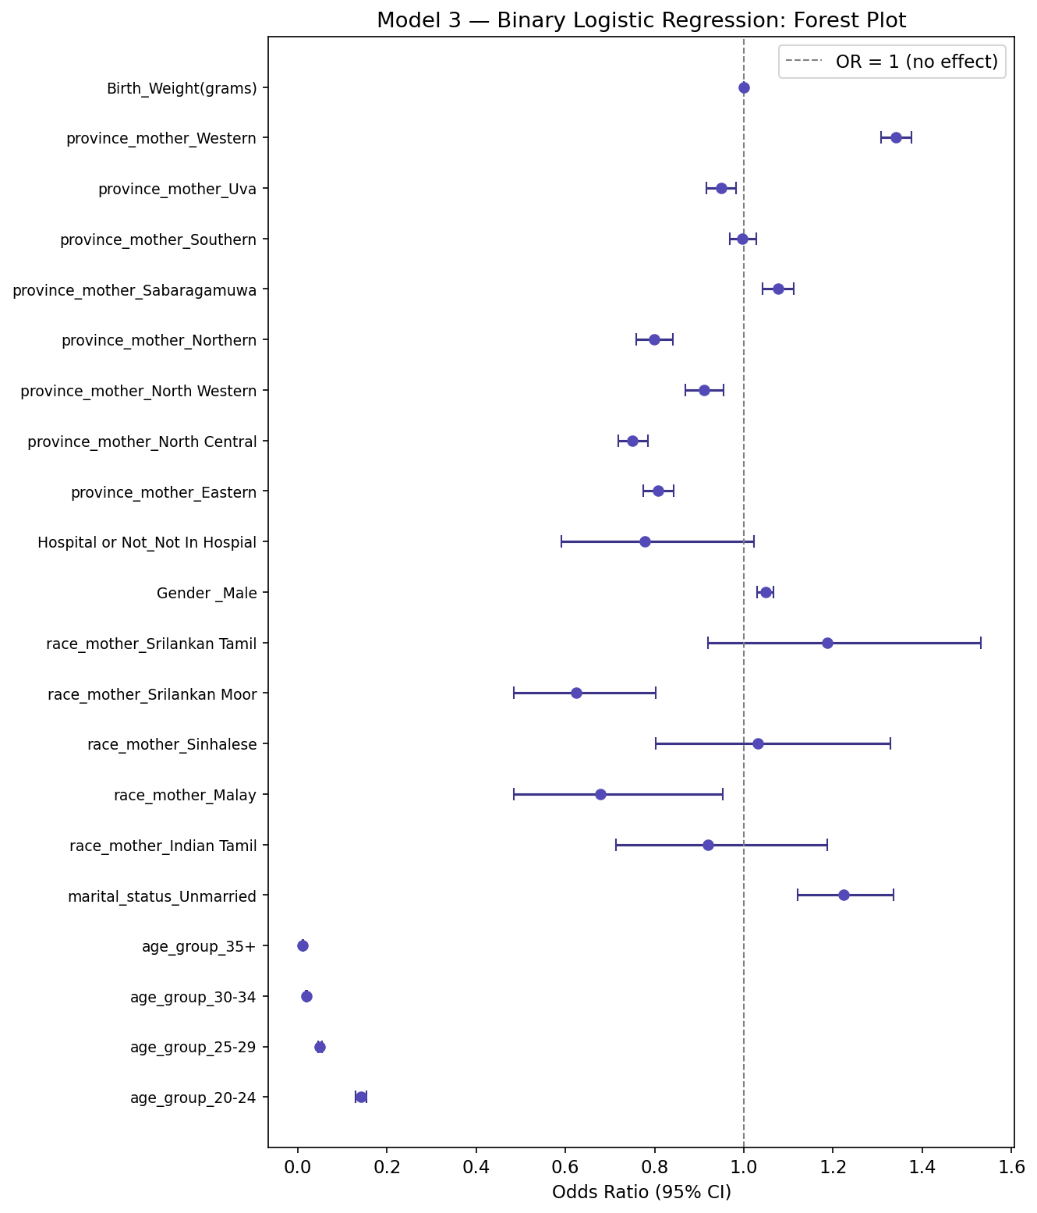
Figure 4.7: Model 3 — Binary Logistic Regression: Forest Plot of Odds Ratios

4.5.3 Interpretation of Key Findings
The predictor age_group_35+ was statistically significant (OR = 0.011, 95% CI: 0.010–0.012, p = 0.0000), indicating decreased odds of being a first birth for this group relative to the reference category, after adjusting for all other variables.
The predictor age_group_30-34 was statistically significant (OR = 0.019, 95% CI: 0.018–0.021, p = 0.0000), indicating decreased odds of being a first birth for this group relative to the reference category, after adjusting for all other variables.
The predictor age_group_25-29 was statistically significant (OR = 0.049, 95% CI: 0.045–0.054, p = 0.0000), indicating decreased odds of being a first birth for this group relative to the reference category, after adjusting for all other variables.

4.5.4 Model Performance: ROC Curve and AUC
The discriminatory ability of the binary logistic regression model was assessed using the Receiver Operating Characteristic (ROC) curve and the Area Under the Curve (AUC). The ROC curve plots the true positive rate (sensitivity) against the false positive rate (1 − specificity) across all probability thresholds. An AUC of 0.5 corresponds to random classification, while an AUC of 1.0 represents perfect discrimination. The AUC for this model was 0.749. Figure 4.8 presents the ROC curve and Figure 4.9 presents the confusion matrix at the 0.5 classification threshold.
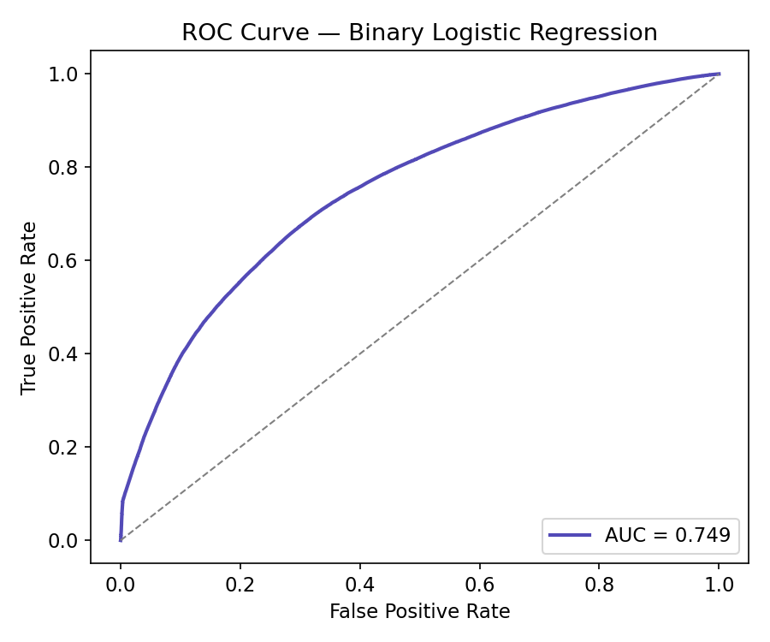
Figure 4.8: ROC Curve — Binary Logistic Regression
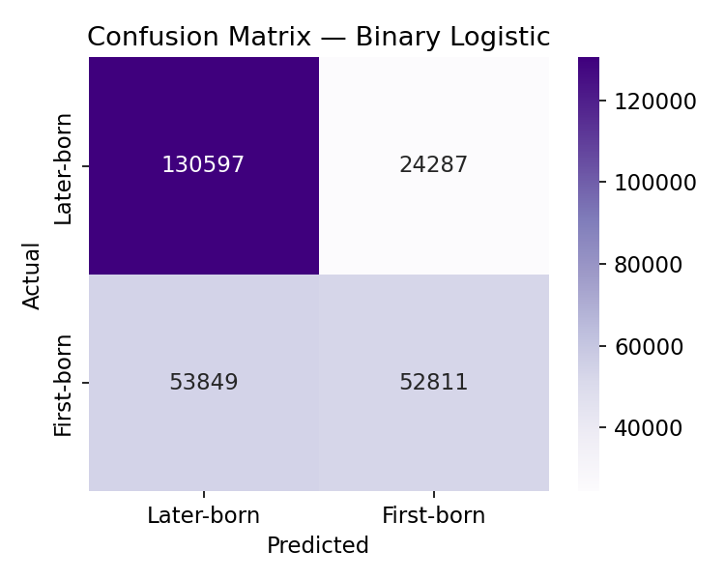
Figure 4.9: Confusion Matrix — Binary Logistic Regression
An AUC of 0.749 indicates acceptable discriminatory performance of the model in distinguishing first births from later births based on the included maternal and birth-related predictor variables.

4.6 Comparison of the Three Models
The three regression models were compared using the Akaike Information Criterion (AIC), Bayesian Information Criterion (BIC), and log-likelihood. Lower AIC and BIC values indicate a better balance of model fit and parsimony, while a higher log-likelihood indicates a better-fitting model. The comparison is presented in Table 4.5.
Table 4.5: Model Comparison — AIC, BIC, and Log-Likelihood
index | Model | Outcome | Effect measure | AIC | BIC | Log-Likelihood
0 | Ordinal Logistic (POM) | Birth order 1-9 (ordered) | Cumulative OR | 544,289.27 | 544,540.66 | -272,120.64
1 | Poisson Regression | Birth order 1-9 (count) | IRR | 722,820.08 | -3,183,414.28 | -361,388.04
2 | Binary Logistic | Parity 1 vs >=2 (binary) | OR | 301,018.88 | 301,249.31 | -150,487.44

The Binary Logistic returned the lowest AIC value (301,018.88), indicating it provides the best balance of fit and parsimony among the three competing specifications. The Poisson Regression had the highest AIC (722,820.08), a difference of ΔAIC = 421,801.20. In general, a ΔAIC greater than 10 provides strong evidence in favour of the lower-AIC model (Burnham & Anderson, 2002).
Each model addresses a different aspect of the research objectives. The ordinal logistic regression (Model 1) is the most informative primary model because it preserves the full ordering of birth order 1 through 9 and yields cumulative odds ratios interpretable across the entire parity distribution. The Poisson regression (Model 2) offers a complementary perspective by treating birth order as a count outcome, consistent with the fertility literature on children-ever-born. The binary logistic regression (Model 3) directly addresses the study's specific objective of characterizing first-born children relative to later-born children, and provides an easily interpretable odds ratio for each predictor with respect to first-birth status. Together, the three models provide a comprehensive and robust characterisation of the parity structure in Sri Lanka's birth registration data.

4.7 Summary of Chapter Findings
This chapter presented the results of descriptive analysis, bivariate chi-square testing, and three multivariable regression models applied to Sri Lanka's birth registration data. The key findings are as follows:
- First-born children accounted for 40.8% of all registered births, with birth order declining progressively at higher parities.
- Chi-square tests identified 6 statistically significant predictors of birth order: age_group, marital_status, race_mother, Gender , Hospital or Not, multiple_birth.
- The Proportional Odds Model (ordinal logistic regression) identified several predictors significantly associated with cumulative birth order, with the top significant predictors shown in Table 4.2.
- The dispersion diagnostic confirmed Poisson regression as the appropriate count model (dispersion ratio = 0.4259).
- The binary logistic regression model achieved an AUC of 0.749, demonstrating the model's ability to discriminate first births from later births.
- Model comparison by AIC identified Binary Logistic as the best-fitting model among the three specifications.

These findings are discussed in the context of Sri Lanka's demographic transition and the existing fertility literature in Chapter Five.

